**1. Virtual Machine Access**

There is a capability for viewing Oracle (and other things) that uses a virtual machine.

You can load this onto your own computer -- it utilizes a web browser to get to Oracle on campus. [If you are not connected via the campus network, VPN also needs to be active each time you use this.]

The capability is VMWare's Horizon Client.

It may also be available on several of the CLCs; if so, you can utilize it there to get to Oracle even though Oracle access might not be directly available in that CLC.

**2. Getting The View Window For Your Own Computer**

To download the software for your own computer, open a browser and go to:

<https://my.vmware.com/web/vmware/details?downloadGroup=CART17Q2_WIN_450&productId=578&rPId=17205>

It's a big file, so it may take some time to download.

It also takes some time to install.

**3. Using the View Client**

Once installed, you'll have to restart and then locate it among "All Programs." (You may want to drag it to your desktop to create an icon for it.)

The next step is different, depending on whether you have ever used a VDI client on your computer or not.

**If you have never used the VDI appliaction on your computer:**

* You will need to double-click “Add Server” in the middle of the window
* You should see a window like the one below
* 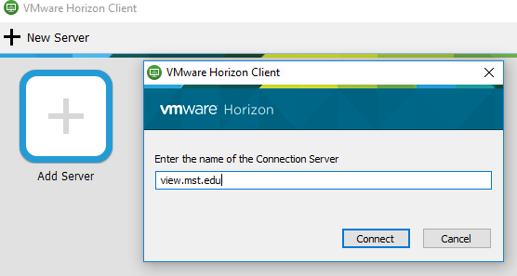In the empty textbox type: view.mst.edu and click connect

**If you have used this application before on your computer:**

* When you open the application you should should see:

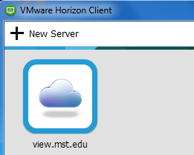

* Click on the cloud icon to be brought to the login page

Enter your campus assigned user name and password and click login:

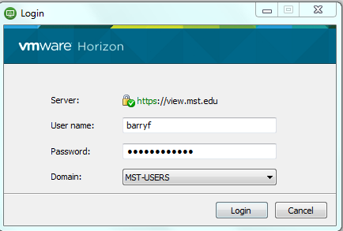

After clicking on the Login button you should see ORACLE-VDI as shown below:

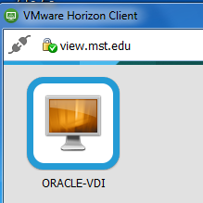

Double-click the icon of the computer screen to launch the virtual desktop.

One the desktop loads, your computer should function as though it were a computer in a CLC on campus. You will see your campus wallpaper and have access to your S drive. You can now find Oracle……SQL*Plus and continue as on HO 2.

**Note: Once finished with virtual desktop, log off of the computer in the same way you would a campus computer. (Start > Logoff) This will automatically close your virtual desktop as well as loging off of the computer.**

**Finally you will also need to disconnect from the virtual machine server. To do this click the picture of the power cord shown in the photo below and close your VMware Horizon Client application.**

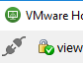

**4. Saving Things**

HO 2 described screen shots and SNIPs for saving information so you can paste it into documents. It also described the use of the S drive.

Another way to access files or save documents is to save to a USB drive with a few extra steps. First insert your USB drive and wait a few seconds for the computer to recognize it. Then, at the top of the VMWare View Client window, select "Connect USB device." A drop down with the name of your USB, probably in the form "(brand name here) USB Mass Storage Device" will show up. Select your USB drive and a window with the contents of your USB drive will open within the VMWare window. Note the location and you can save anything to the USB drive accessed through the VMWare window.

Of course you can still use your S Drive or Google Drive account if you find that easier.

**5. Final Notes**

Don't forget to **Logout** of the virtual desktop and **Disconnect** from the server when you are finished.

Let me know of anything else that should be mentioned.

This has been revised to reflect this semester's situation. If you have suggestions for improving it for the future, please let me know.